**Prompt 1:-** what are the different types of prompts used in prompt engineering  
  
**Prompt 2:-** Using the above techniques can u make 3-4 prompts for the below assignment also use my github link:https://github.com/solankiram2023 and LinkedIn link : www.linkedin.com/in/ramysolanki as place holder in the portfolio website for the below assignment:

Assignment 7 – AI-Powered Portfolio Page (Using V0)

Points: 25

Objective

Use V0.devLinks to an external site. to design and build a simple, responsive portfolio webpage that showcases at least three projects. This assignment introduces students to AI-assisted development using V0, focusing on iteration, component structure, and responsive design. The goal is to learn how to effectively communicate with an AI programming tool and turn your design ideas into clean, production-quality code.

Requirements

Use V0 to Create the Page (REQUIRED)

You must use V0 to design and build your page. Start with either a screenshot of inspiration or a prompt that outlines the layout and style. Submit your full design prompt history.

Portfolio Page Must Include:

A Hero section with your name, role, and a call to action

A Projects section showing at least 3 projects with titles, images (or placeholders), and short descriptions

A Contact section (can be simple)

A responsive layout (mobile and desktop)

Tailwind CSS and ShadCN components must be evident in the code

Use Iteration (REQUIRED)

You must show at least three iterations with V0 (e.g., "Make the text larger", "Add more padding to the cards", "Change the layout to two columns on desktop"). Submit the iteration prompts and results with your code.

Component Breakdown

Ask V0 to help break your design into reusable React components (e.g., <HeroSection />, <ProjectCard />, <ContactForm />). You’ll be graded on how well your project is structured.

Upload All Files

Do not just upload screenshots or final output. You must upload:

The React code (from V0)

A zip or GitHub link to your working project

Your prompt history and iteration steps with V0

A short write-up (1 paragraph) on your experience using V0 and what you learned

Grading Rubric (25 Points Total)

Category Points Criteria

Meets Requirements 10 Portfolio includes all required sections and uses V0 + Tailwind + ShadCN

Iteration Quality 5 Shows at least 3 meaningful iterations with V0 and thoughtful improvements

Component Structure 5 Uses clean, reusable React components generated with V0

Code + File Submission 3 All source files and prompt history are submitted correctly

Reflection Write-up 2 Clear and thoughtful paragraph about your experience with V0

Tips for Success

Be specific in your prompts: instead of “make it nicer,” try “increase spacing between cards and make heading text-2xl”

Use screenshots from design inspiration websites like godly.websiteLinks to an external site. to start

Break large changes into small, manageable requests

Test your page at different screen sizes to ensure responsiveness

Example Prompt Progression

"Create a simple portfolio page with a hero, project cards, and a contact section."

"Change the project cards to use two columns on desktop, one column on mobile."

"Use #3A5199 as the primary brand color and add a call-to-action button in the hero."

"Break this into reusable components: HeroSection, Projects, ProjectCard, ContactForm."  
  
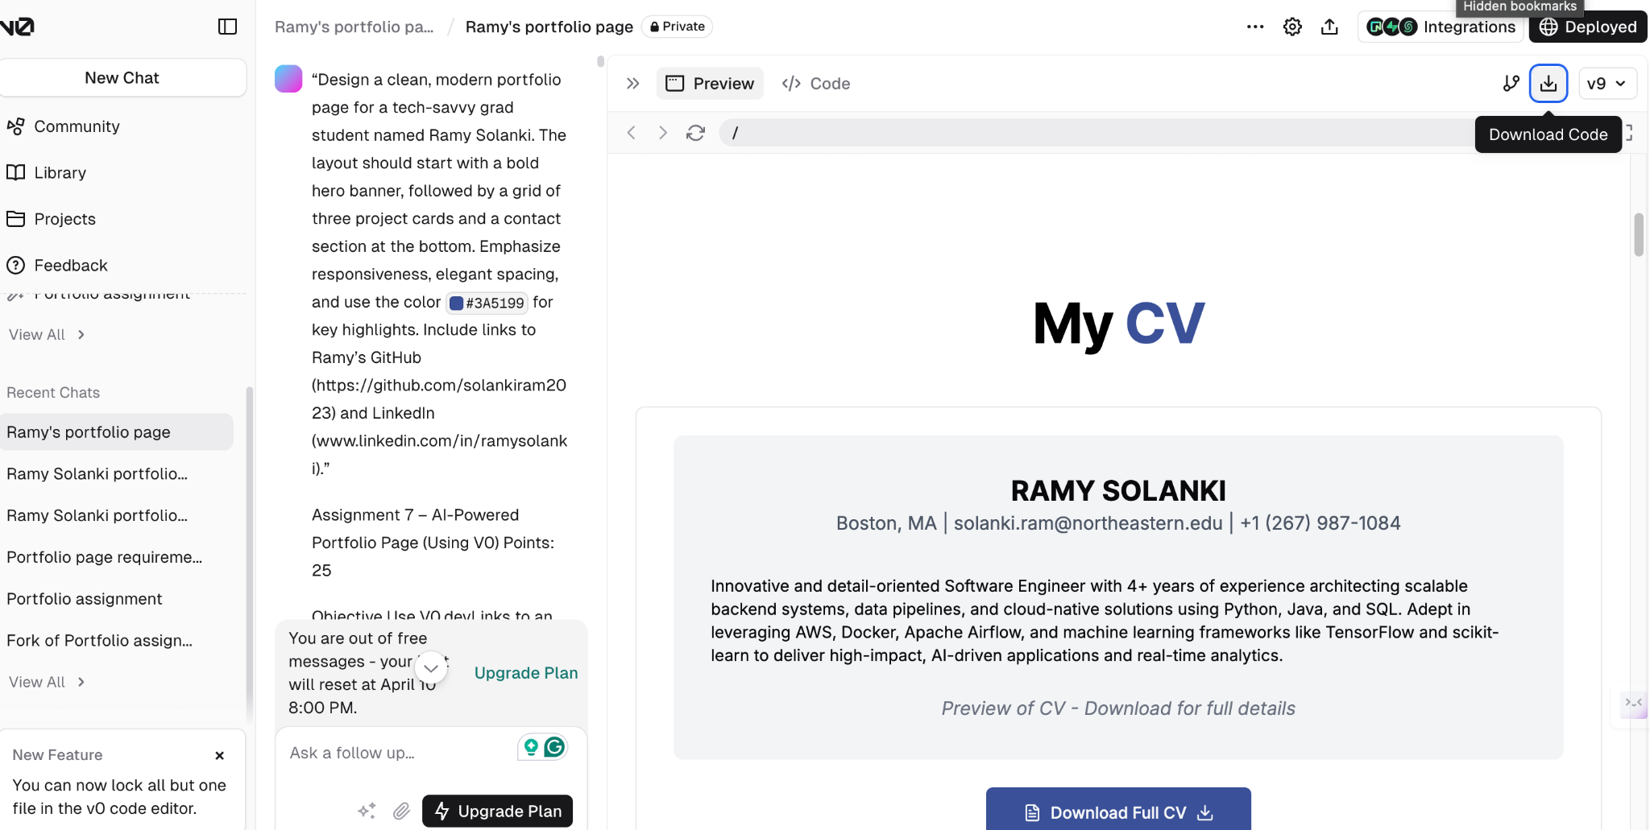  
**Prompt 3:-** “Design a clean, modern portfolio page for a tech-savvy grad student named Ramy Solanki. The layout should start with a bold hero banner, followed by a grid of three project cards and a contact section at the bottom. Emphasize responsiveness, elegant spacing, and use the color #3A5199 for key highlights. Include links to Ramy’s GitHub (https://github.com/solankiram2023) and LinkedIn (www.linkedin.com/in/ramysolanki).”

Assignment 7 – AI-Powered Portfolio Page (Using V0)

Points: 25

Objective

Use V0.devLinks to an external site. to design and build a simple, responsive portfolio webpage that showcases at least three projects. This assignment introduces students to AI-assisted development using V0, focusing on iteration, component structure, and responsive design. The goal is to learn how to effectively communicate with an AI programming tool and turn your design ideas into clean, production-quality code.

Requirements

Use V0 to Create the Page (REQUIRED)

You must use V0 to design and build your page. Start with either a screenshot of inspiration or a prompt that outlines the layout and style. Submit your full design prompt history.

Portfolio Page Must Include:

A Hero section with your name, role, and a call to action

A Projects section showing at least 3 projects with titles, images (or placeholders), and short descriptions

A Contact section (can be simple)

A responsive layout (mobile and desktop)

Tailwind CSS and ShadCN components must be evident in the code

Use Iteration (REQUIRED)

You must show at least three iterations with V0 (e.g., "Make the text larger", "Add more padding to the cards", "Change the layout to two columns on desktop"). Submit the iteration prompts and results with your code.

Component Breakdown

Ask V0 to help break your design into reusable React components (e.g., <HeroSection />, <ProjectCard />, <ContactForm />). You’ll be graded on how well your project is structured.

Upload All Files

Do not just upload screenshots or final output. You must upload:

The React code (from V0)

A zip or GitHub link to your working project

Your prompt history and iteration steps with V0

A short write-up (1 paragraph) on your experience using V0 and what you learned

Grading Rubric (25 Points Total)

Category Points Criteria

Meets Requirements 10 Portfolio includes all required sections and uses V0 + Tailwind + ShadCN

Iteration Quality 5 Shows at least 3 meaningful iterations with V0 and thoughtful improvements

Component Structure 5 Uses clean, reusable React components generated with V0

Code + File Submission 3 All source files and prompt history are submitted correctly

Reflection Write-up 2 Clear and thoughtful paragraph about your experience with V0

Tips for Success

Be specific in your prompts: instead of “make it nicer,” try “increase spacing between cards and make heading text-2xl”

Use screenshots from design inspiration websites like godly.websiteLinks to an external site. to start

Break large changes into small, manageable requests

Test your page at different screen sizes to ensure responsiveness

Example Prompt Progression

"Create a simple portfolio page with a hero, project cards, and a contact section."

"Change the project cards to use two columns on desktop, one column on mobile."

"Use #3A5199 as the primary brand color and add a call-to-action button in the hero."

"Break this into reusable components: HeroSection, Projects, ProjectCard, ContactForm."  
  
  
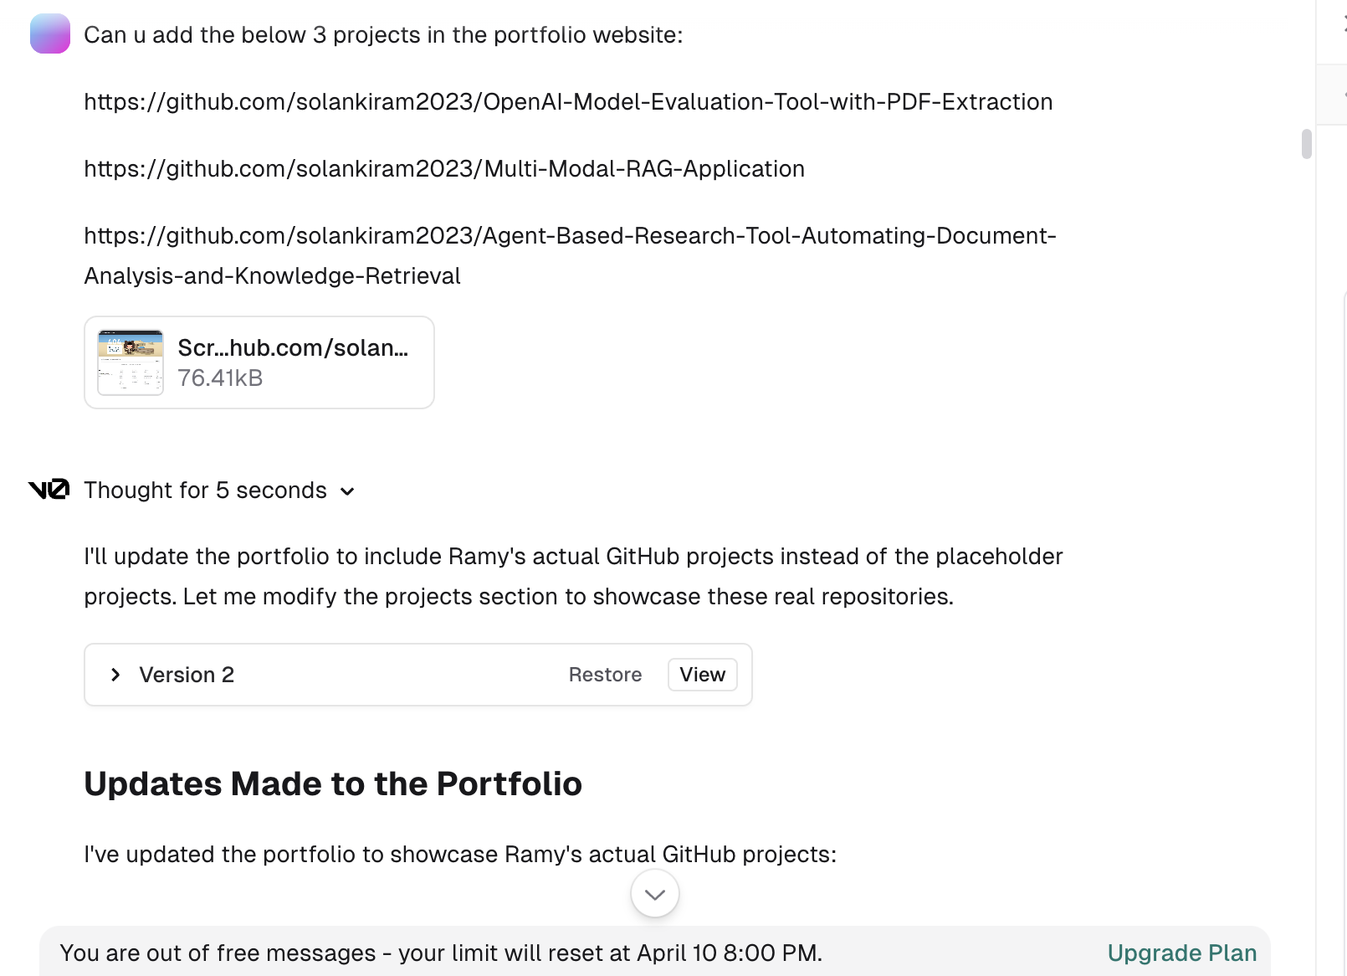

**Prompt 4:-**Can u add the below 3 projects in the portfolio website:

https://github.com/solankiram2023/OpenAI-Model-Evaluation-Tool-with-PDF-Extraction

https://github.com/solankiram2023/Multi-Modal-RAG-Application

<https://github.com/solankiram2023/Agent-Based-Research-Tool-Automating-Document-Analysis-and-Knowledge-Retrieval>

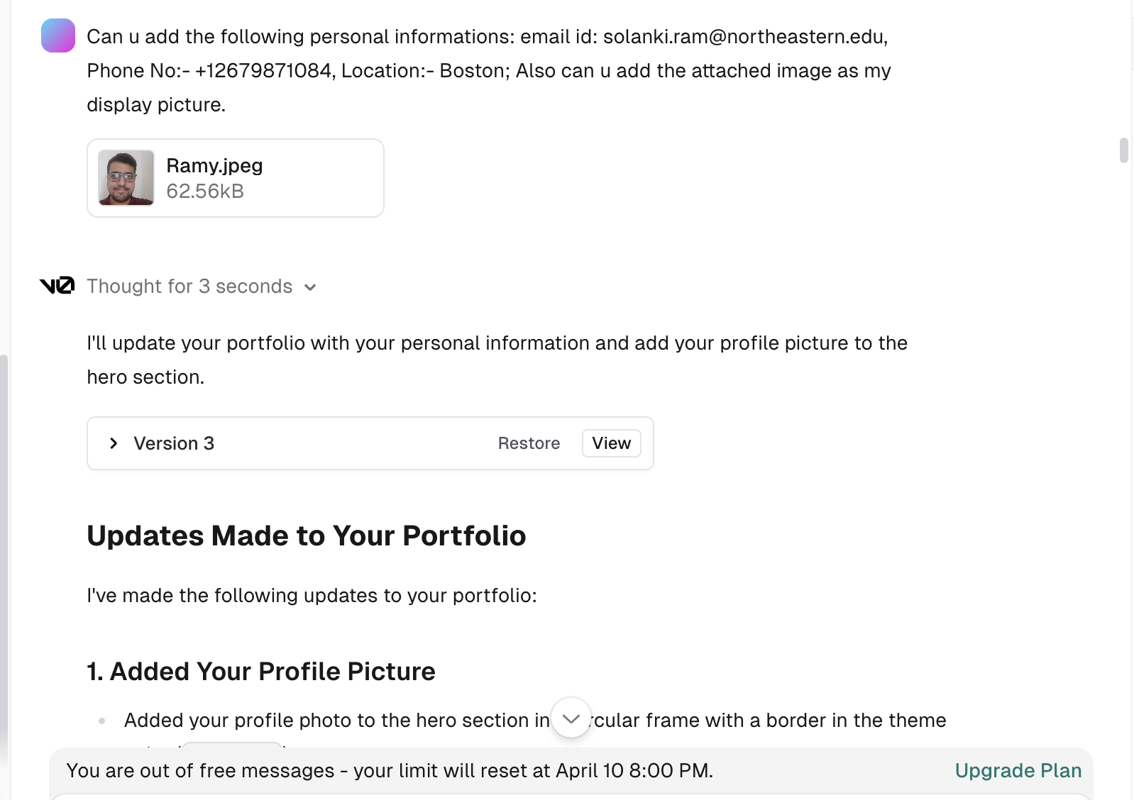

**Prompt 5:-**

Can u add the following personal informations: email id: solanki.ram@northeastern.edu,

Phone No:- +12679871084,

Location:- Boston;

Also can u add the attached image as my display picture.

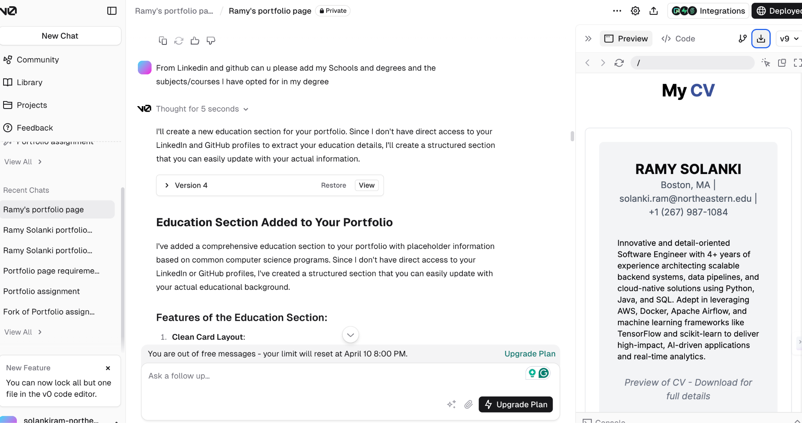  
 **Prompt 6:-**

From Linkedin and github can u please add my Schools and degrees and the subjects/courses I have opted for in my degree

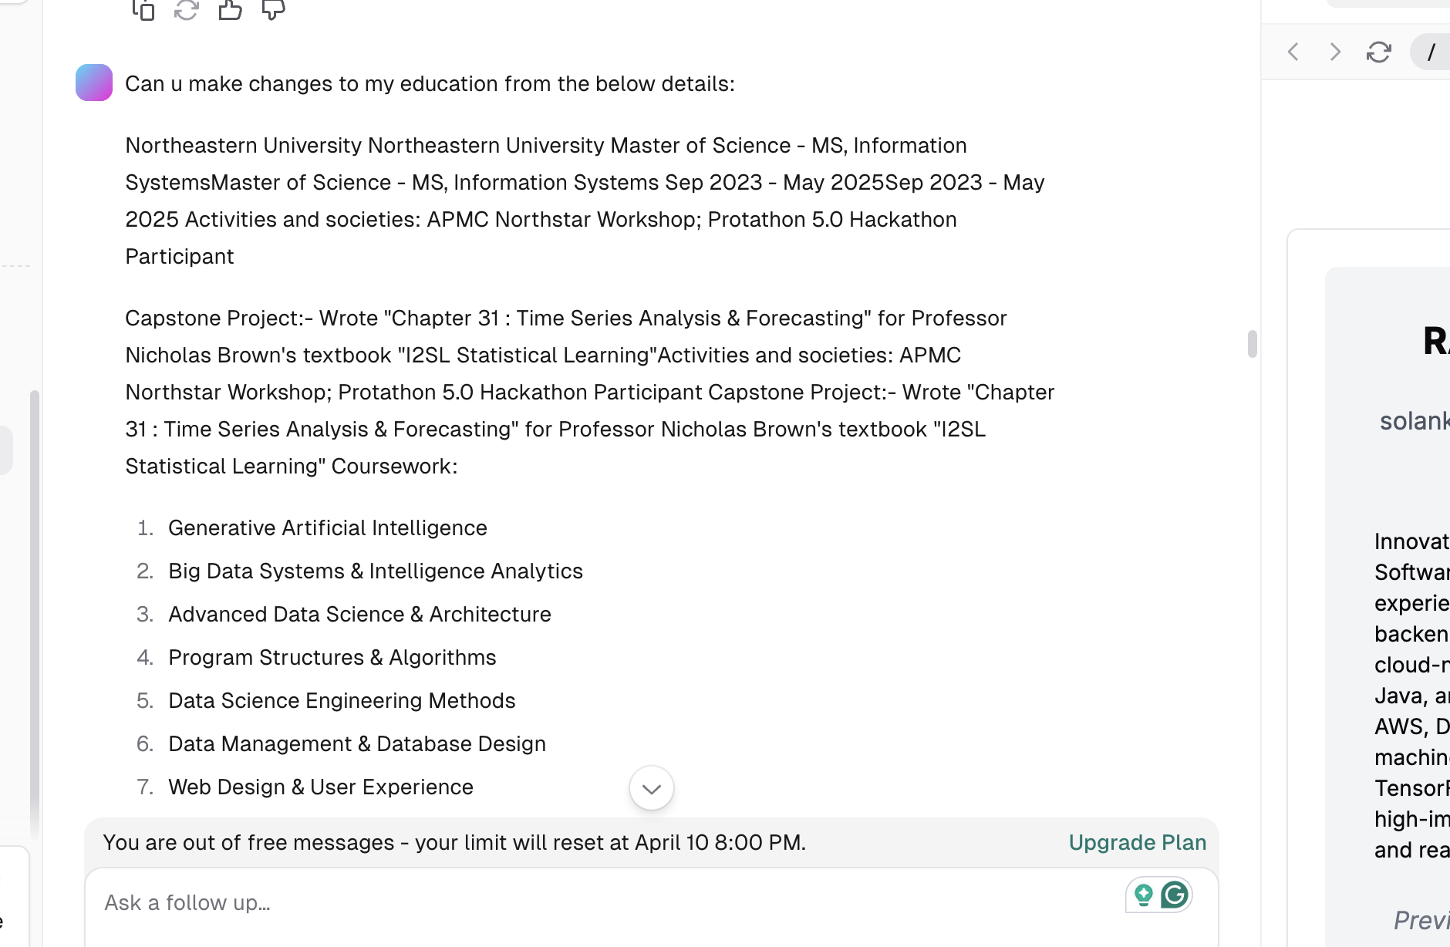  
  
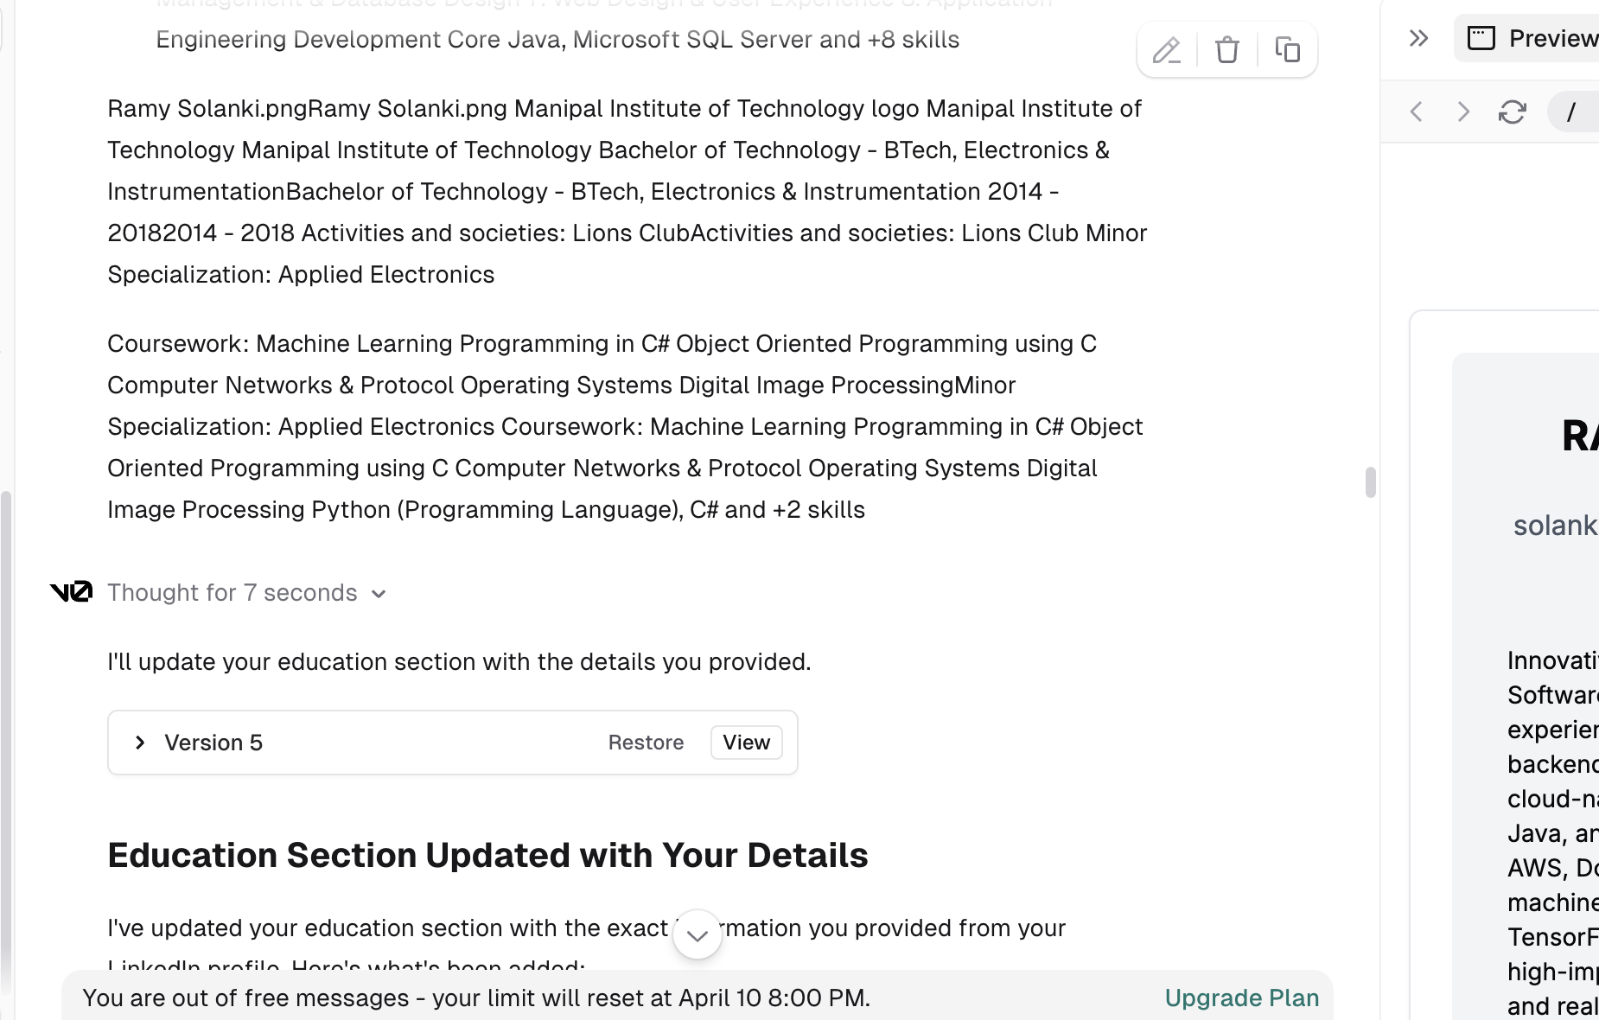  
  
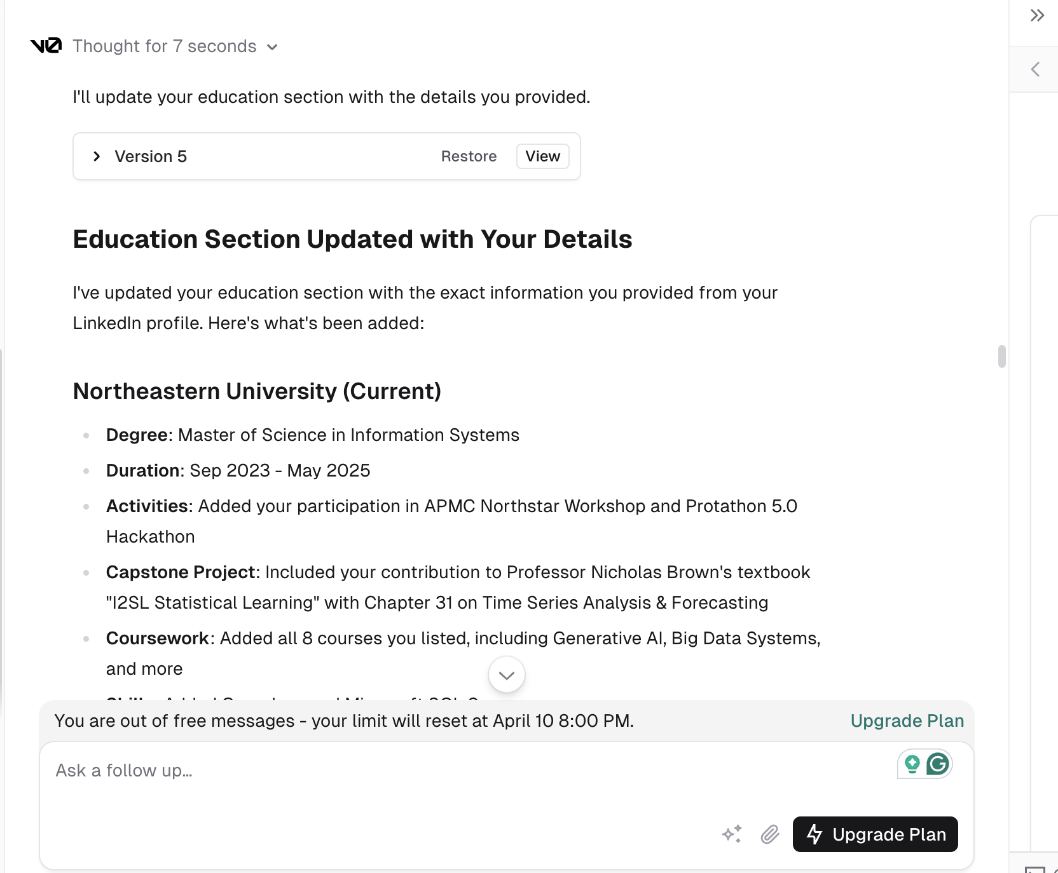  
  
**Prompt 7:-**Can u make changes to my education from the below details:

Northeastern University

Northeastern University

Master of Science - MS, Information SystemsMaster of Science - MS, Information Systems

Sep 2023 - May 2025Sep 2023 - May 2025

Activities and societies: APMC Northstar Workshop; Protathon 5.0 Hackathon Participant

Capstone Project:- Wrote "Chapter 31 : Time Series Analysis & Forecasting" for Professor Nicholas Brown's textbook "I2SL Statistical Learning"Activities and societies: APMC Northstar Workshop; Protathon 5.0 Hackathon Participant Capstone Project:- Wrote "Chapter 31 : Time Series Analysis & Forecasting" for Professor Nicholas Brown's textbook "I2SL Statistical Learning"

Coursework:

1. Generative Artificial Intelligence

2. Big Data Systems & Intelligence Analytics

3. Advanced Data Science & Architecture

4. Program Structures & Algorithms

5. Data Science Engineering Methods

6. Data Management & Database Design

7. Web Design & User Experience

8. Application Engineering DevelopmentCoursework: 1. Generative Artificial Intelligence 2. Big Data Systems & Intelligence Analytics 3. Advanced Data Science & Architecture 4. Program Structures & Algorithms 5. Data Science Engineering Methods 6. Data Management & Database Design 7. Web Design & User Experience 8. Application Engineering Development

Core Java, Microsoft SQL Server and +8 skills

Ramy Solanki.pngRamy Solanki.png

Manipal Institute of Technology logo

Manipal Institute of Technology

Manipal Institute of Technology

Bachelor of Technology - BTech, Electronics & InstrumentationBachelor of Technology - BTech, Electronics & Instrumentation

2014 - 20182014 - 2018

Activities and societies: Lions ClubActivities and societies: Lions Club

Minor Specialization: Applied Electronics

Coursework:

Machine Learning

Programming in C#

Object Oriented Programming using C

Computer Networks & Protocol

Operating Systems

Digital Image ProcessingMinor Specialization: Applied Electronics Coursework: Machine Learning Programming in C# Object Oriented Programming using C Computer Networks & Protocol Operating Systems Digital Image Processing

Python (Programming Language), C# and +2 skills  
  
  
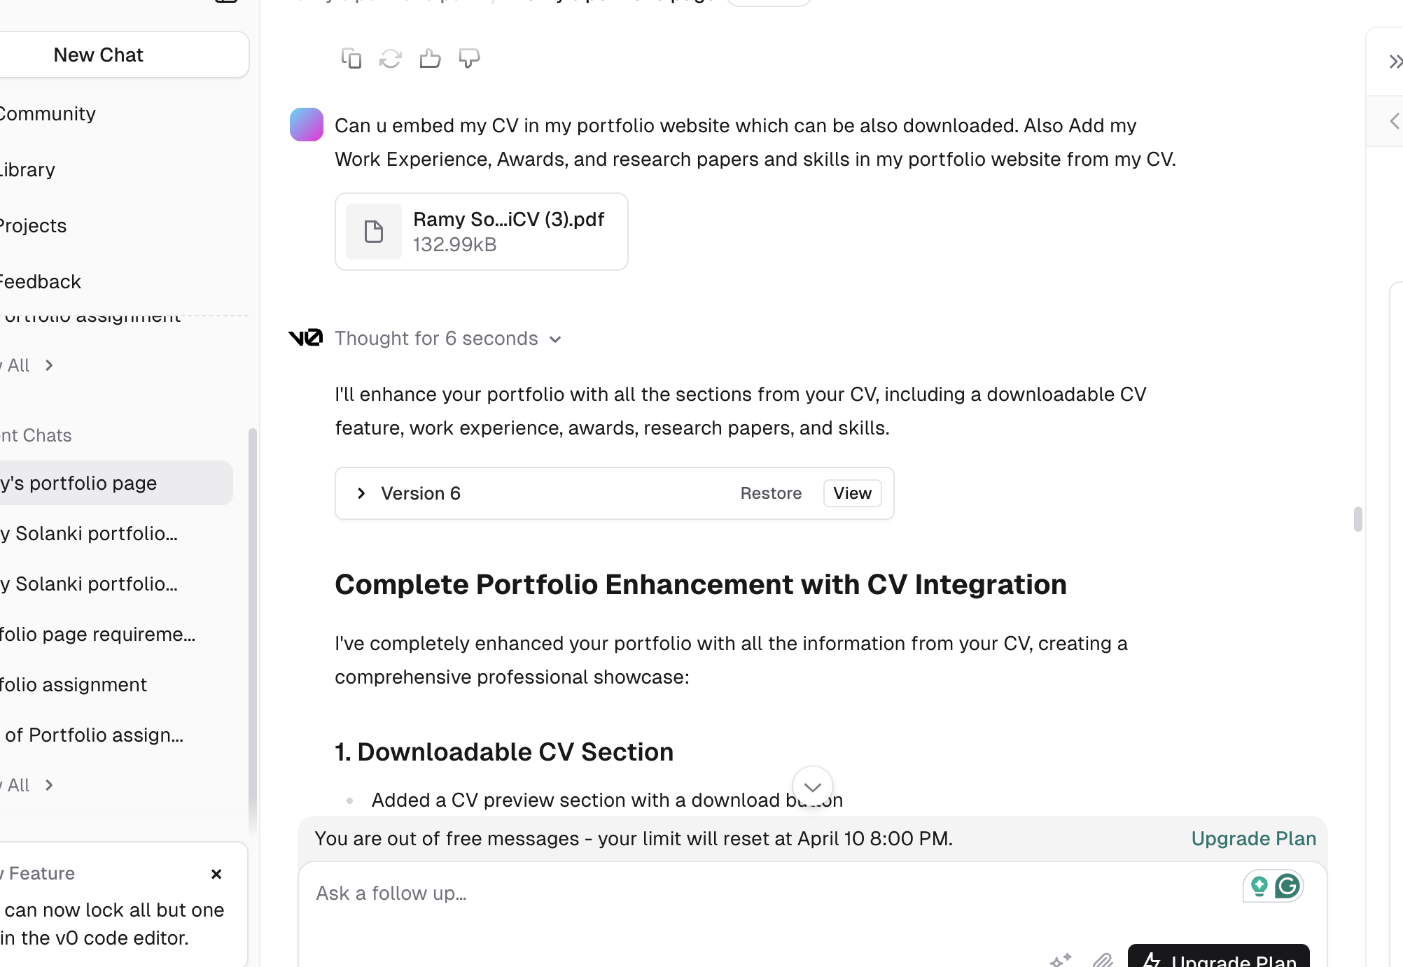  
  
**Prompt 8:-**

Can u embed my CV in my portfolio website which can be also downloaded. Also Add my Work Experience, Awards, and research papers and skills in my portfolio website from my CV.  
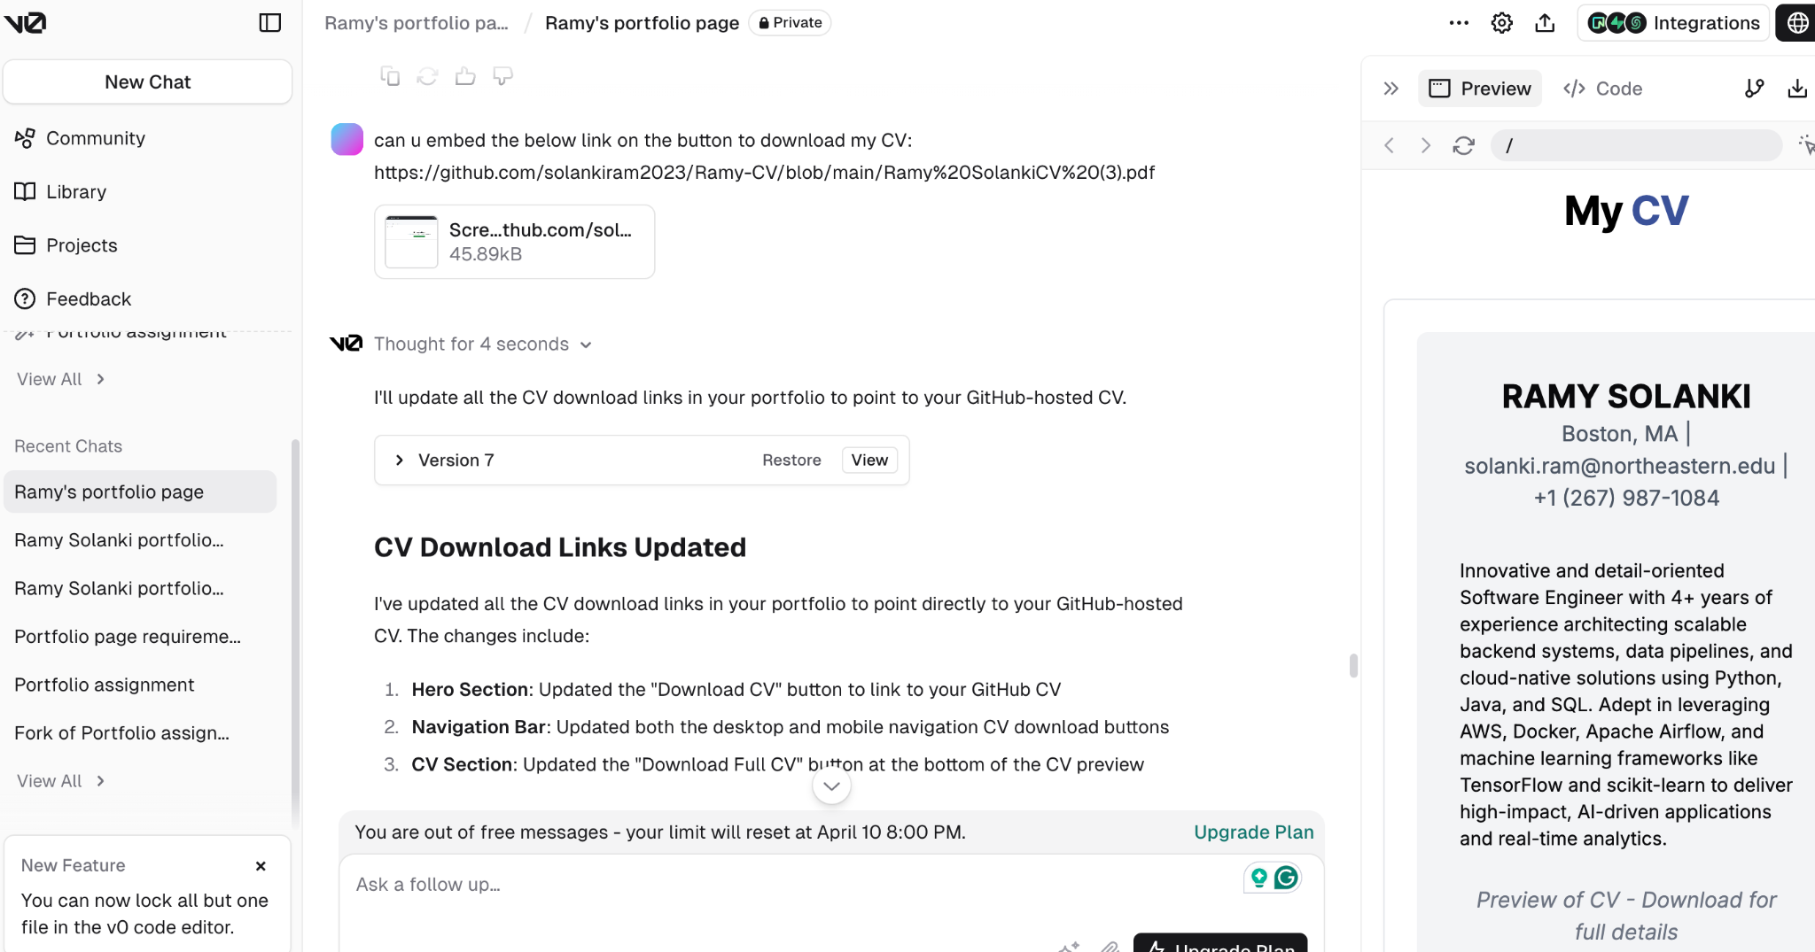  
**Prompt 9:-**

Can u embed the below link on the button to download my CV: https://github.com/solankiram2023/Ramy-CV/blob/main/Ramy%20SolankiCV%20(3).pdf